**Step 1: Turn your computer on then press Del or F2 (depend on your computer’s mainboard) to enter the system BIOS**

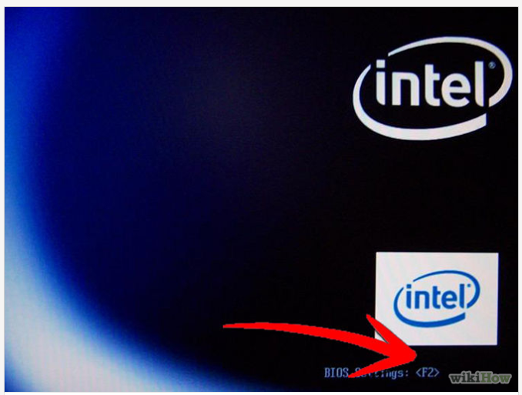

**Step 2: Go to Boot menu and choose Boot From CD/DVD.**

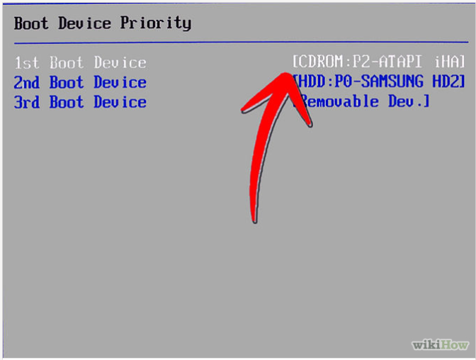

**Step 3: Press F10 to save the configuration and exit BIOS then reset your computer.**

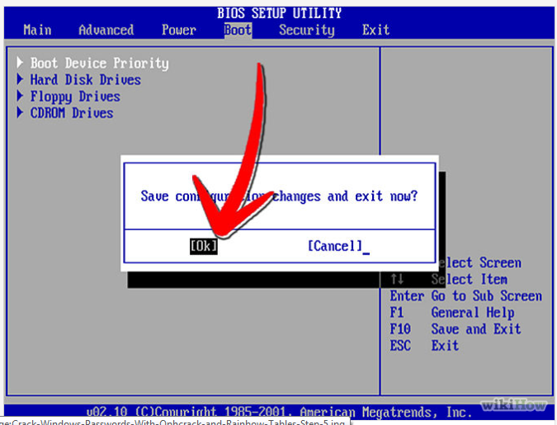

**Step 4: Insert Windows 7 DVD into your DVD drive then start up your computer, Windows 7 will be loading files.**

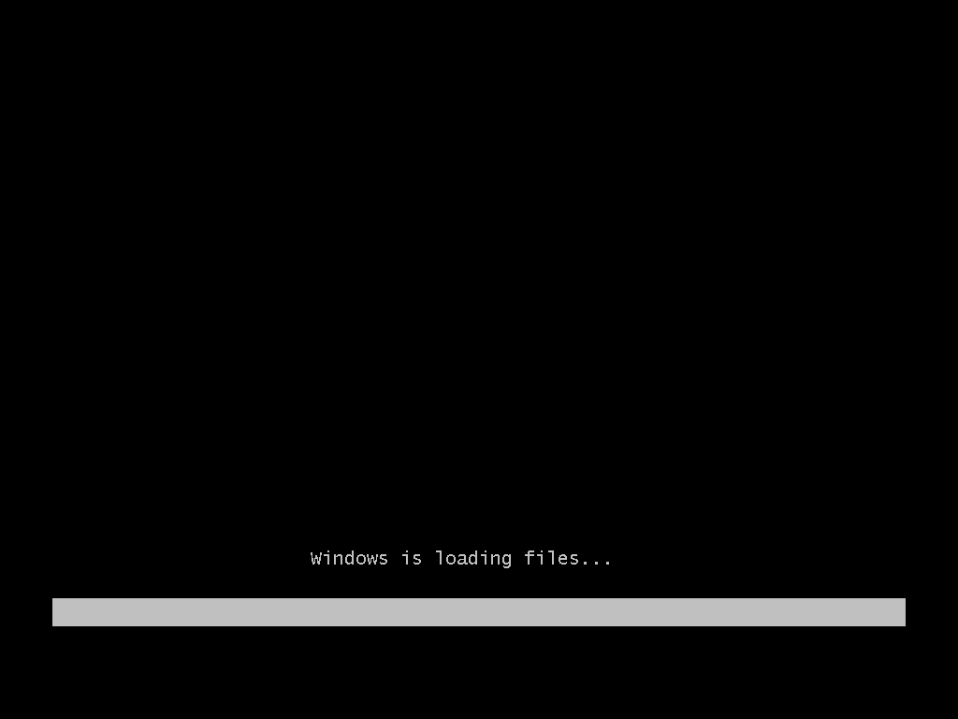

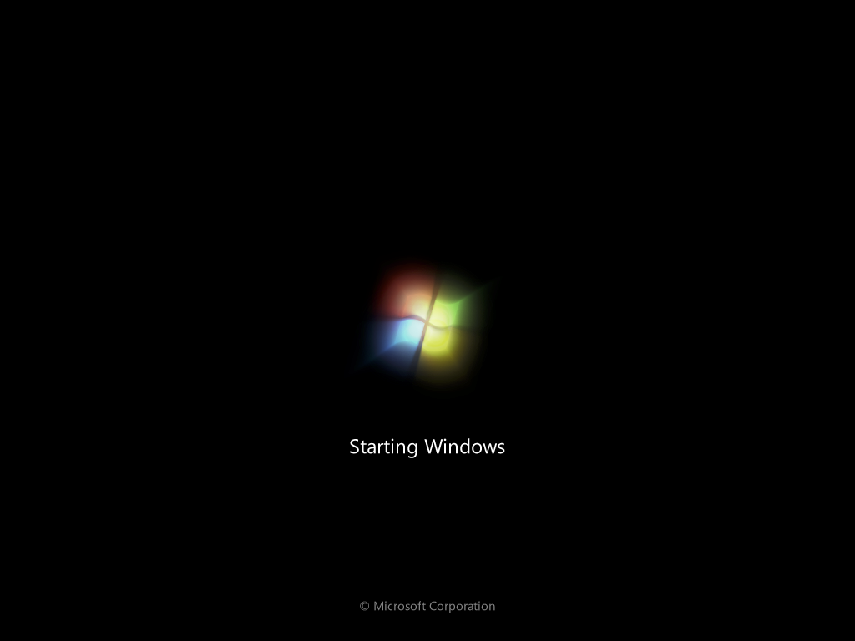

**Step 5: Select these parts: Language to Install,Time and currency format, Keyboard or input method. Then click Next.**

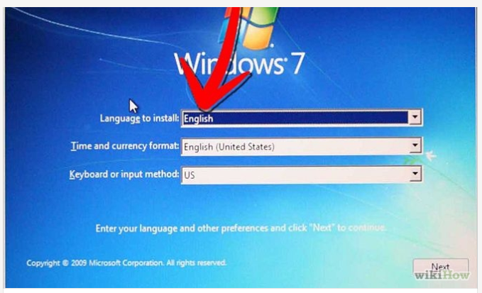

**Step 6: Choose Install Now if you want to install Windows 7. Choose the Windows 7 version that you want to install in 'Select the operating system you want to install' . Here we choose Windows 7 Ultimate then click next (depending on your Windows DVD, this step is an option).**

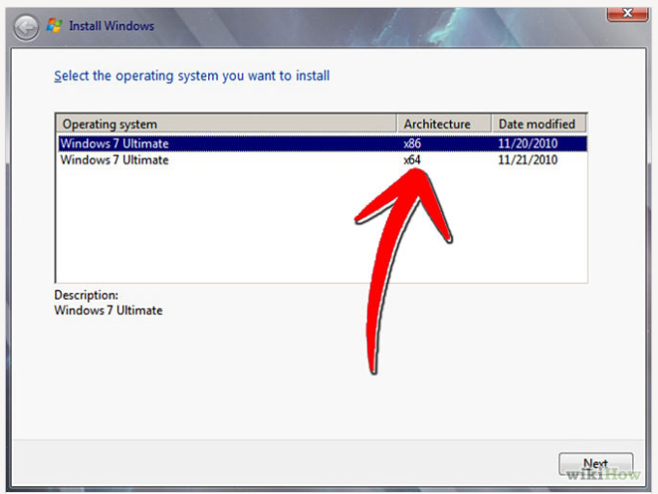

**STEP 7: Click 'I accept the license terms' in 'Please read the license' then click Next.**

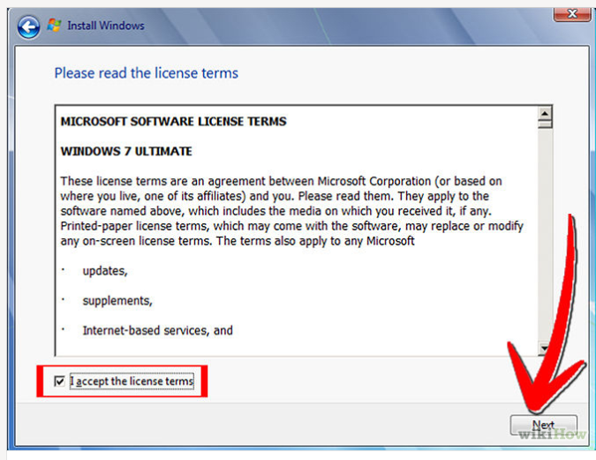

**Step 8: Choose 'Upgrade' in 'Which type of installation do you want' if you want to upgrade from an older Windows version to Windows 7, 'Custom (advance)' if you want to install a new version of Windows.**

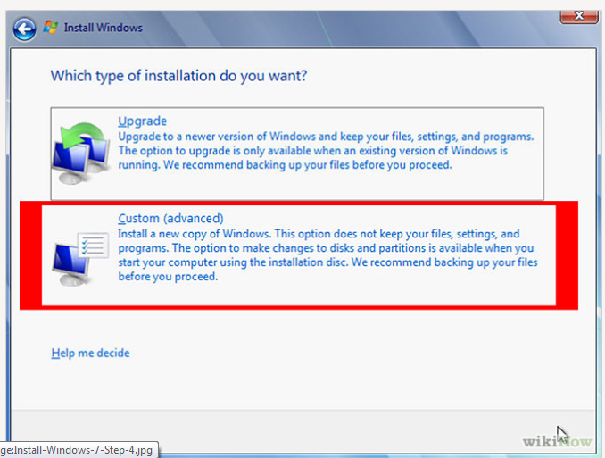

**Step 9: Choose Partition for installation, if your computer has only one hard disk, it will be easy for selection, but if it has some Partition, you will have to consider which Partition to choose.**

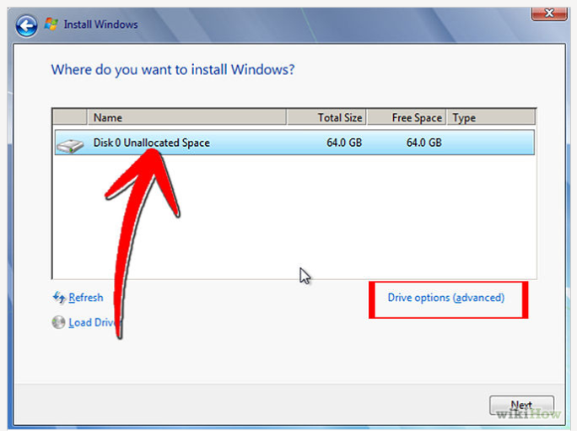

**Step 10: Wait for Installing Windows to progress. Your computer might be restarted during the process.**

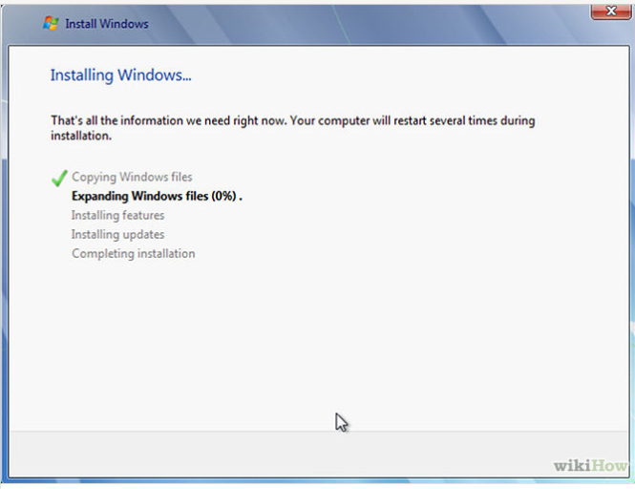 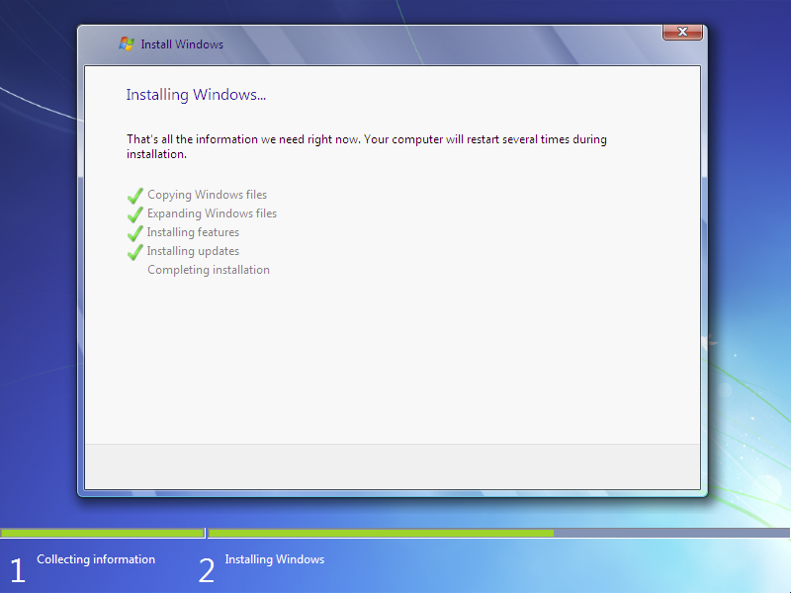

**Step11: The third and fourth step will also complete instantly like the first step.** **After that it will automatically restart after 15 seconds and continue the setup. You can also click Restart now to restart without any delays.**

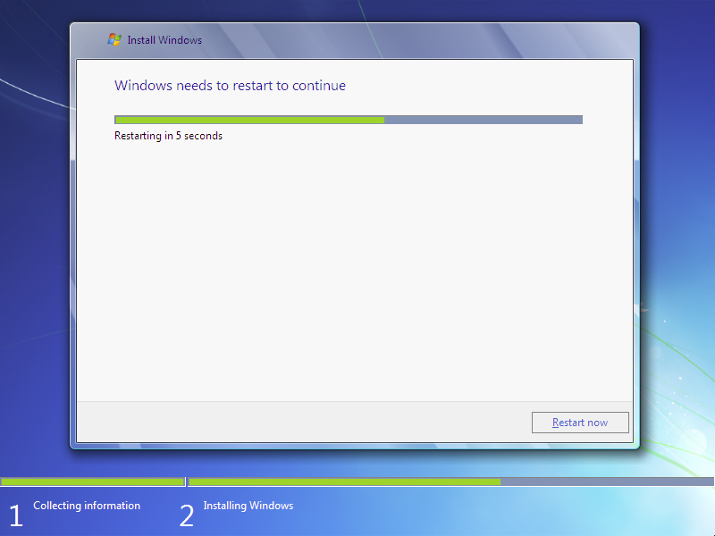

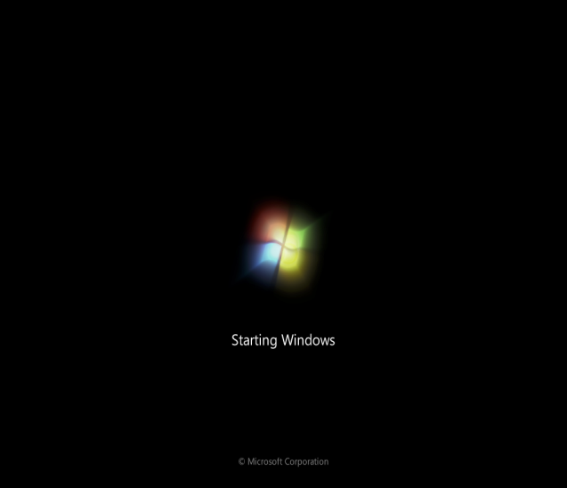 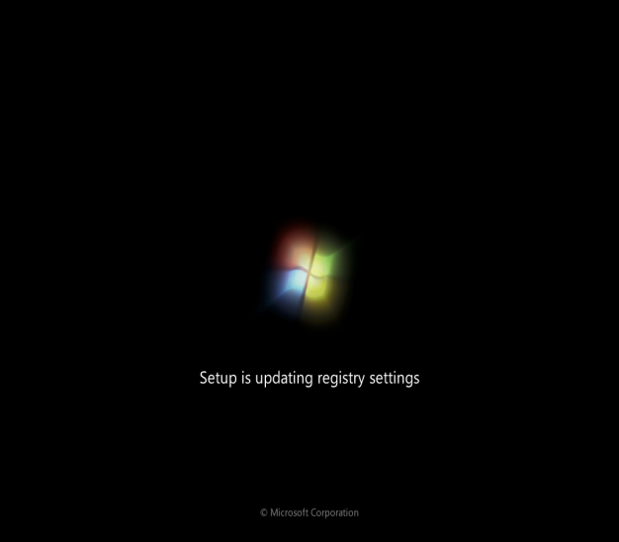

Step 12: After restarting for the first time, it will continue the setup. This is the last step so it will take the most time than the previous steps.

** **

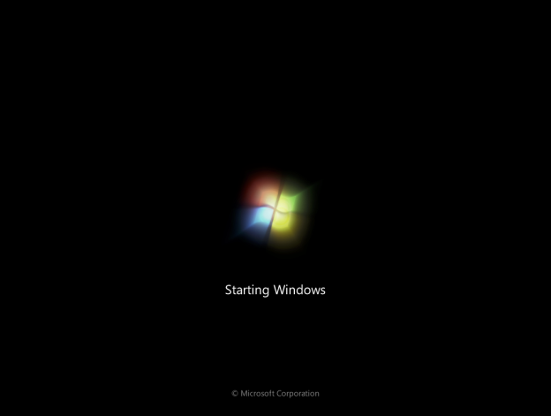 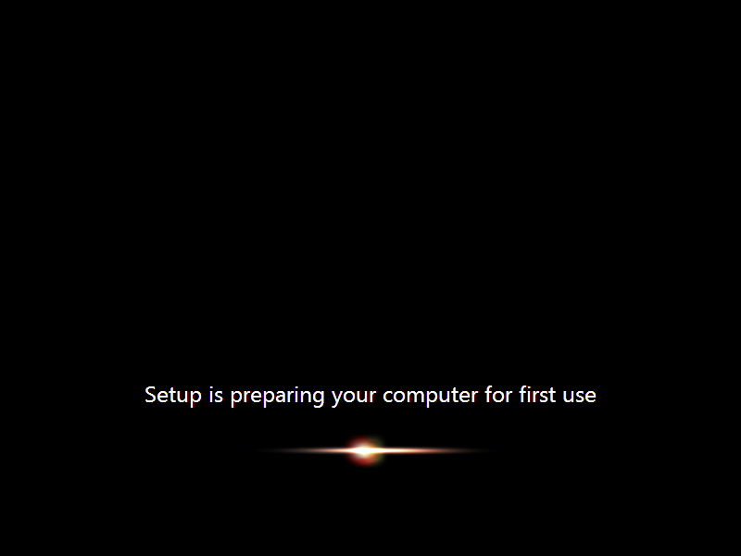

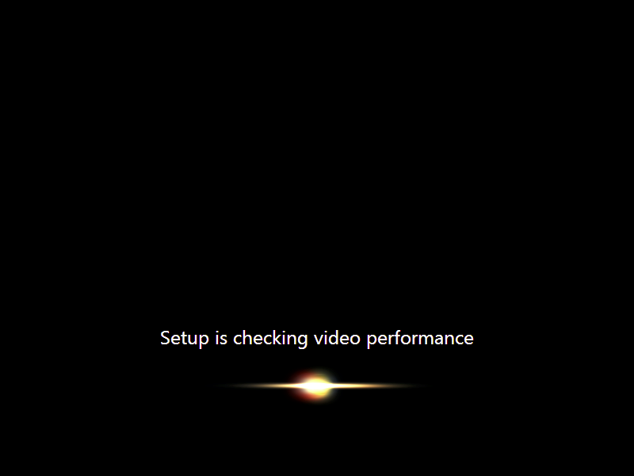

Type your desired user name in the text-box and click **Next**. It will automatically fill up the computer name.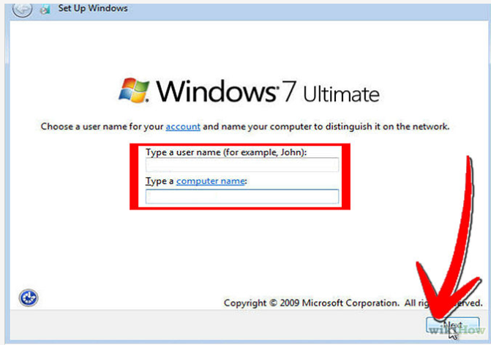

**Step12:** If you want to set a password, Type a password for your account, you can also Type a password hint to help in case of forgetting the password in the future, and then click Next.

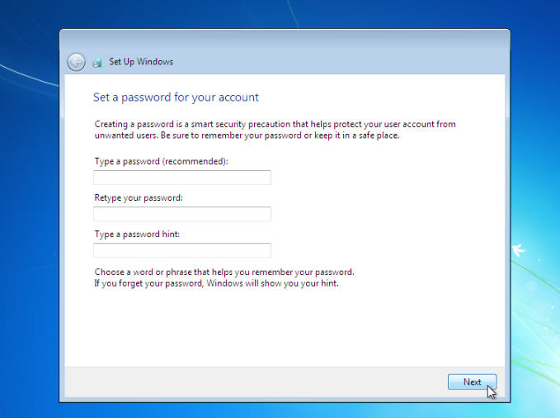

**Step13: Type in activation code or key for your license in Product key box if you have any. Click Next.**

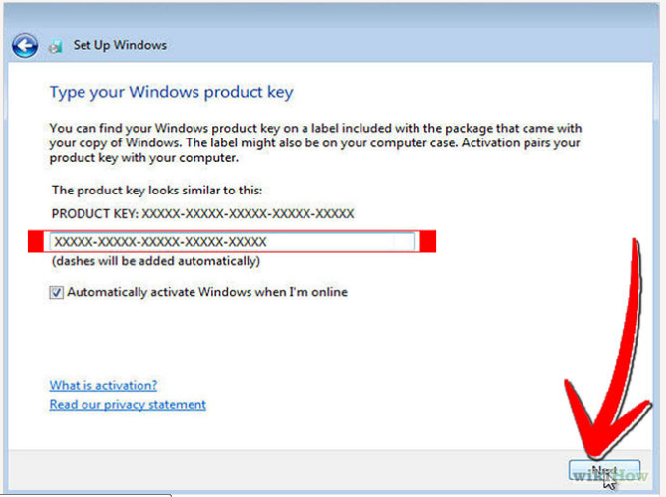

**Step14: Choose how to protect your Windows. Here we choose Use recommended settings.**

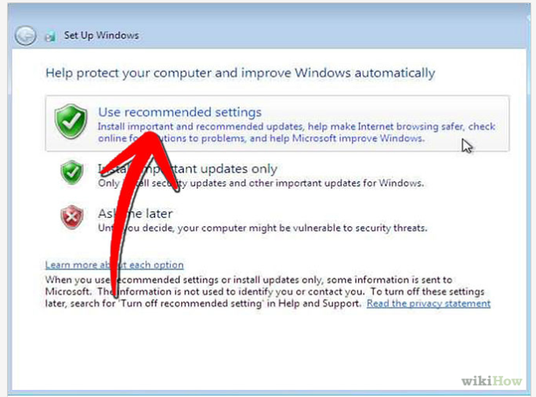

**Step15: Set up your Time zone then click Next.**

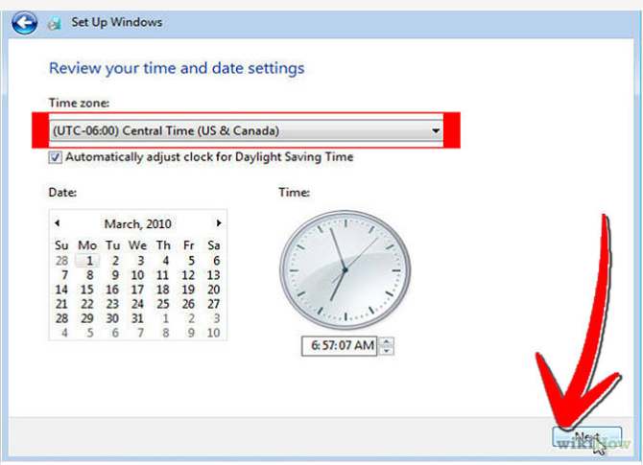

**Step16:** If you are connected to any network, it will ask you to set the network's location.**Choose an option from 3 choices: Public Network, Work Network, Home Network. Choose Home Network for using Internet at home.**

